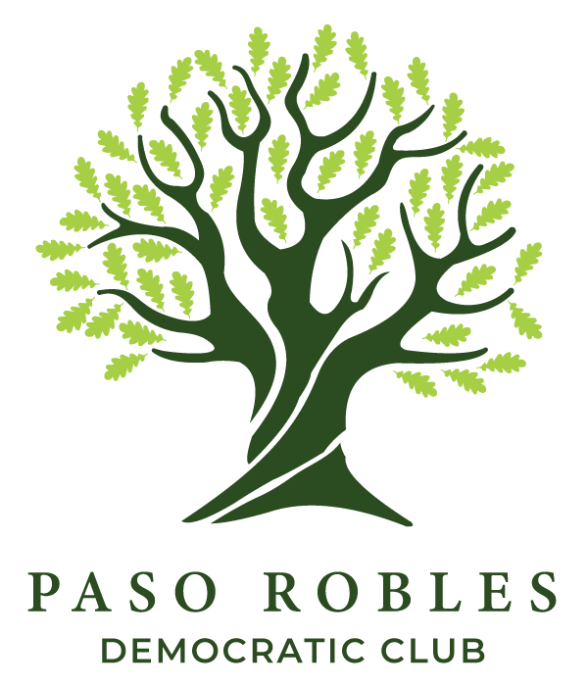

The Steve Martin Community Service Award

Thank you for considering for nomination a member of our community for the Steve Martin Community Service Award! Awardees will be chosen by the members of the Paso Robles Democratic Club’s Steve Martin Community Service Award Committee, considering community leaders of any political affiliation. The award will be given to a member of the Paso Robles, San Miguel, Templeton or Shandon community who, through their actions, has made valuable contributions to their community in leadership in at least one of the following areas:
  - Building or expanding cooperation among businesses, non-profits, local organizations and local government.
  - Expanding or strengthening democratic participation among local residents.
  - Improving local conditions in housing, agriculture, the environment, education, safety, or social services.

The criteria for the award are meant to be expansive in terms of work done that resulted in concrete or symbolic gains for the community or culture of the community. The centermost values embodied in the criteria are the functioning of the democratic institutions of the community, i.e. the city and county government, school board, or resident and voter participation. Other important areas of impact that are taken into consideration are quality of life, housing, education, environment, economy, and culture.

The awardee will receive a handsome tabletop award along with a check for $500. The award will be presented by a member of the Awards Committee joined by community sponsors, committee members and the Democratic Club President and Vice President at each Paso Robles Democratic Club December Holiday Event. The media will be invited.

Please fill out the attached nomination form and return it to:
PRDC
P.O. Box 1074
Paso Robles, CA 93447

Or make your nomination online at:
Steve Martin Service Award Nomination
(Link on: https://www.pasoroblesdemocrats.org)

Nominations must be received no later than Friday, October 30th, 2026
Questions? Contact us at: pasoroblesdemocrats@gmail.com

